Lesson 2 Demo 4: Create DaemonSets

This section will guide you to:

* Create DaemonSets

This lab has one sub-section, namely:

1. Creating DaemonSets

**Note:** If you don’t have an existing Kubernetes cluster, refer to the Demo 1 of Lesson 1.

**Step 1:** Creating DaemonSets

* Create a DaemonSet in a YAML file with the command

*vi daemonset.yaml*

* Add the following code to the *daemonset.yaml* file to describe a DaemonSet that runs the *fluentd-elasticsearch* Docker image:

*apiVersion: apps/v1*

*kind: DaemonSet*

*metadata:*

*name: fluentd-elasticsearch*

*namespace: kube-system*

*labels:*

*k8s-app: fluentd-logging*

*spec:*

*selector:*

*matchLabels:*

*name: fluentd-elasticsearch*

*template:*

*metadata:*

*labels:*

*name: fluentd-elasticsearch*

*spec:*

*tolerations:*

*# this toleration is to have the daemonset runnable on master nodes*

*# remove it if your masters can't run pods*

*- key: node-role.kubernetes.io/master*

*effect: NoSchedule*

*containers:*

*- name: fluentd-elasticsearch*

*image: quay.io/fluentd_elasticsearch/fluentd:v2.5.2*

*resources:*

*limits:*

*memory: 200Mi*

*requests:*

*cpu: 100m*

*memory: 200Mi*

*volumeMounts:*

*- name: varlog*

*mountPath: /var/log*

*- name: varlibdockercontainers*

*mountPath: /var/lib/docker/containers*

*readOnly: true*

*terminationGracePeriodSeconds: 30*

*volumes:*

*- name: varlog*

*hostPath:*

*path: /var/log*

*- name: varlibdockercontainers*

*hostPath:*

*path: /var/lib/docker/containers*

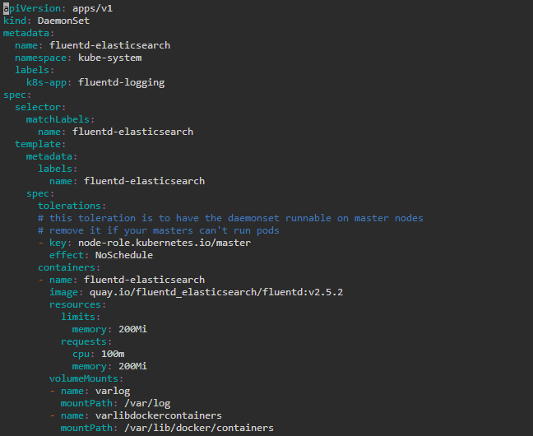

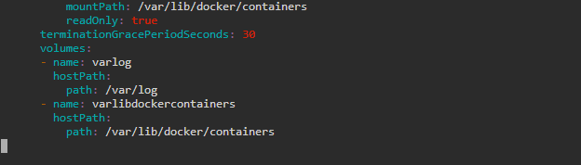

**Note:** Press **Esc** button and enter **:wq** to save and exit the text editor

* Create a DaemonSet using the YAML file

*kubectl apply -f daemonset.yaml*

